**SSRS Report: -**

1. Given suburb and city, display median rental value, median yearly income, and value changes of the property within 1 km radius.

Report:

1. Given suburb and city, display local public transport within 1km radius - update data sets.

Stored Procedure: 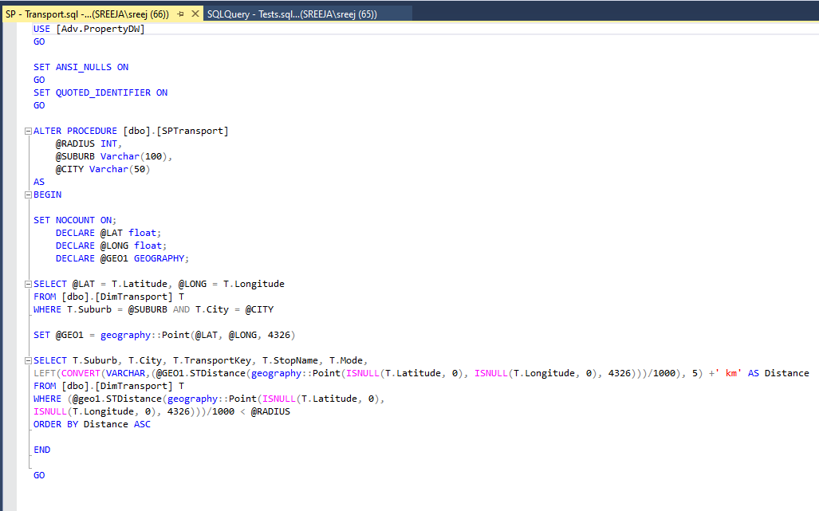

1. Given suburb and city, display local schools within 1 km radius.

Report: 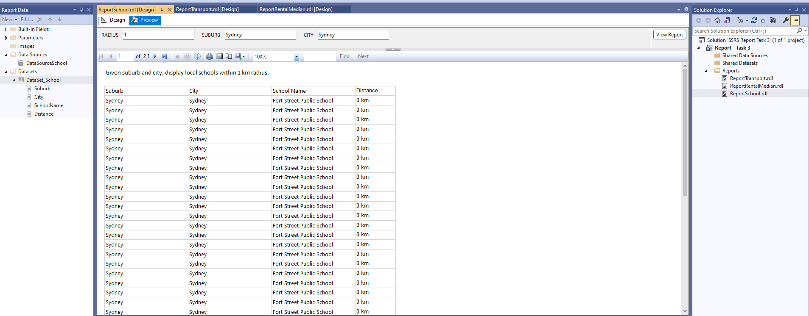

1. Given suburb and city, display crime rate within 1 km radius.

Report: 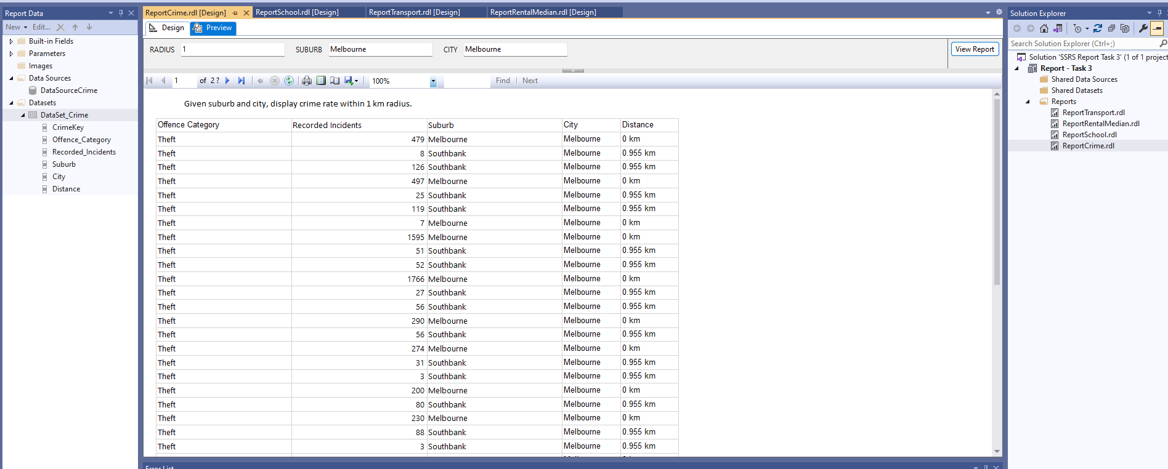

1. Given suburb and city, display property value of the area in Column chart and line chart of 1 year, 5 years and 10 years value.

